**Cloud Computing: UE20CS352**

**Assignment 4**

**-Adithya M, Section K**

**-PES1UG20CS621**

la.jpg Screenshot of Zookeeper Server having started.

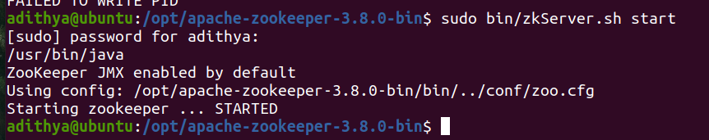

2a.jpg Screenshot of Listing of the created ZNodes

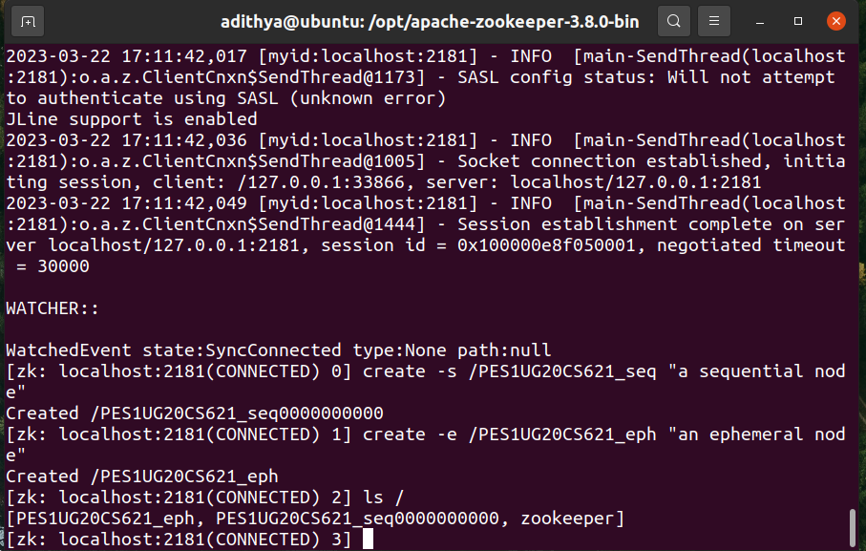

2b.jpg Screenshot of Listing of the deleted ephemeral node

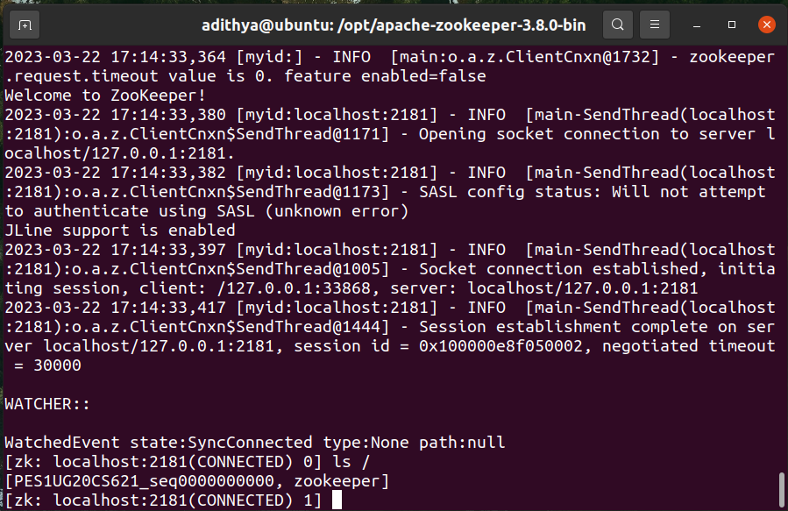

2c.jpg Screenshot of Data and Metadata associated with the created sequential znode.

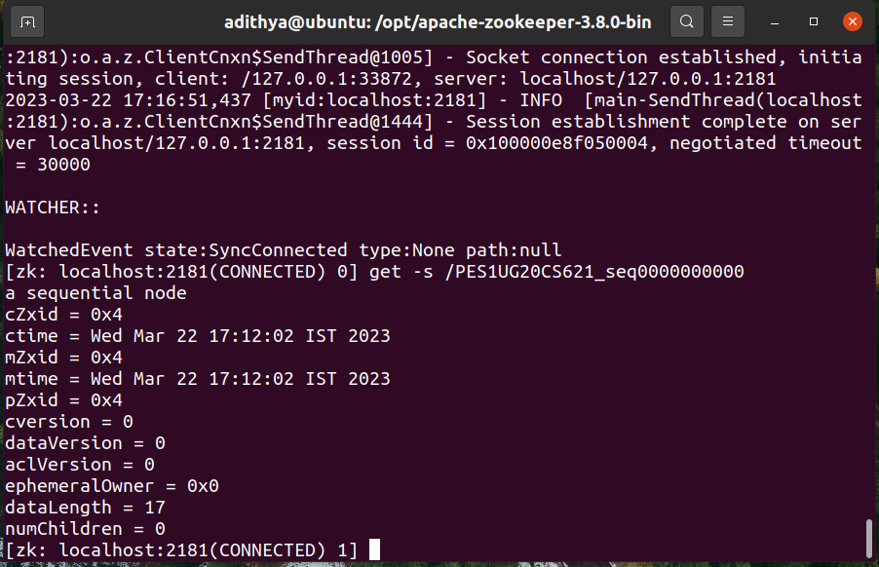

2d.jpg Screenshot of Listing of all the children nodes

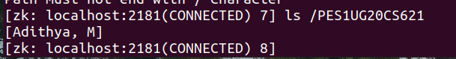

3a.jpg Screenshot of each of the clients listing all the znodes

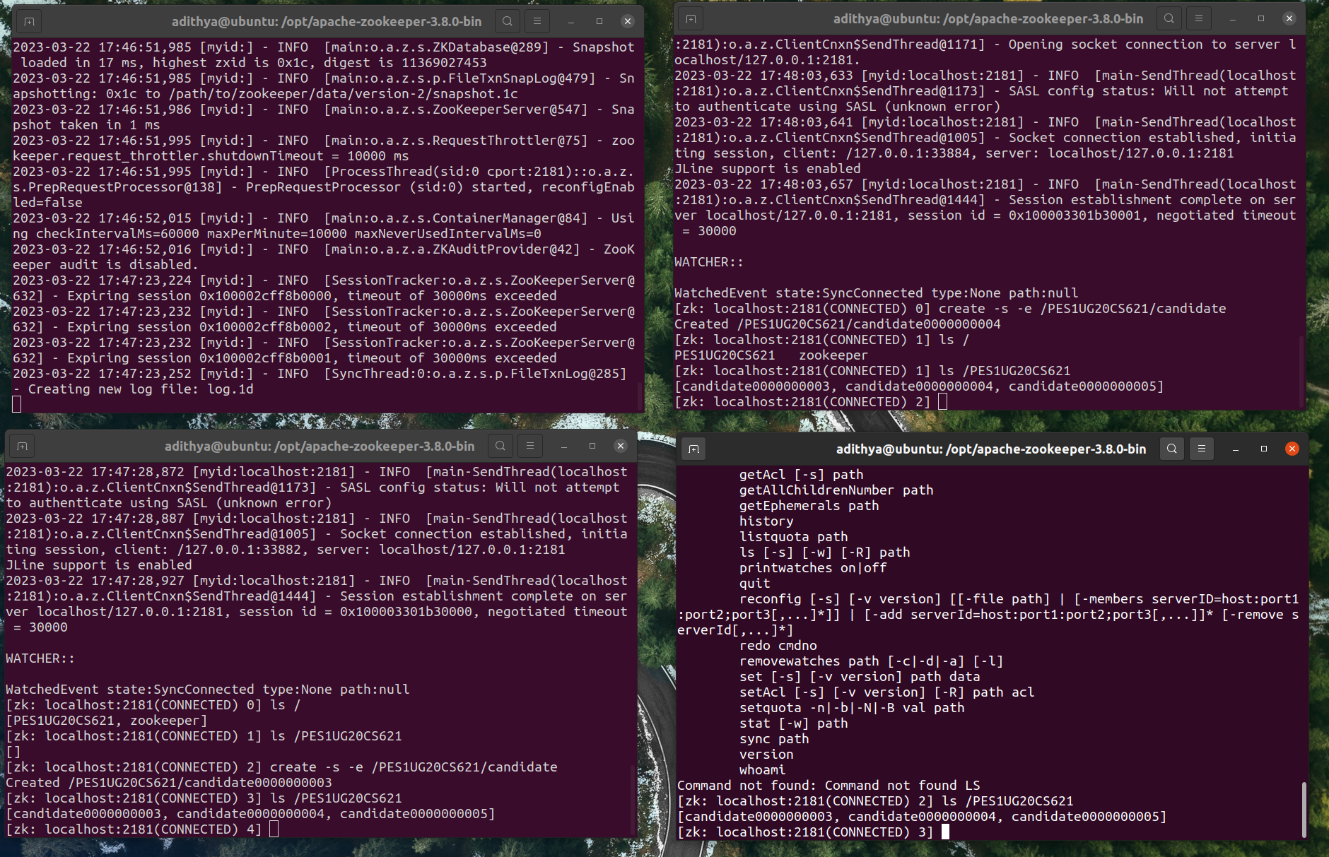

3b.jpg Screenshot of the Watched Event and the Zookeeper Server logs.

